Table of Contents

1. Login Wireframe 2

2. Registration Wireframe 2

3. New Post by Registered User 3

4. Display Posts 3

5. Search Wireframe 4

6. Admin User management 5

7. Admin Category Management 5

# Login Wireframe

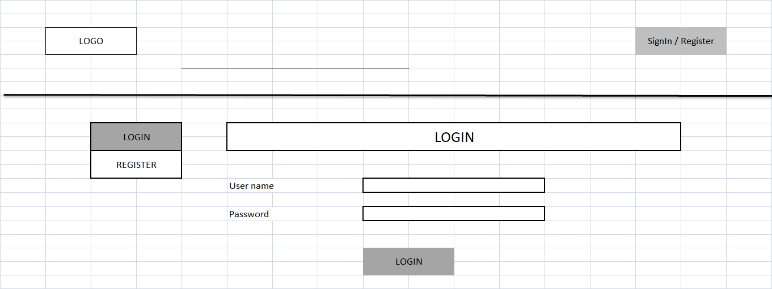

# Registration Wireframe

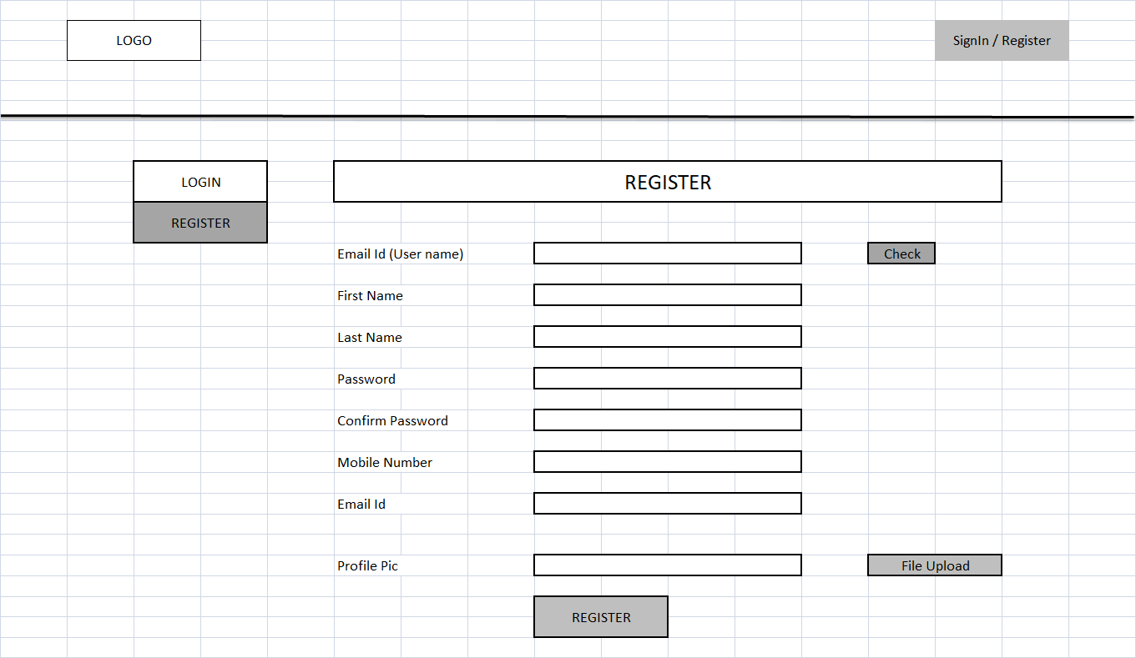

# New Post by Registered User

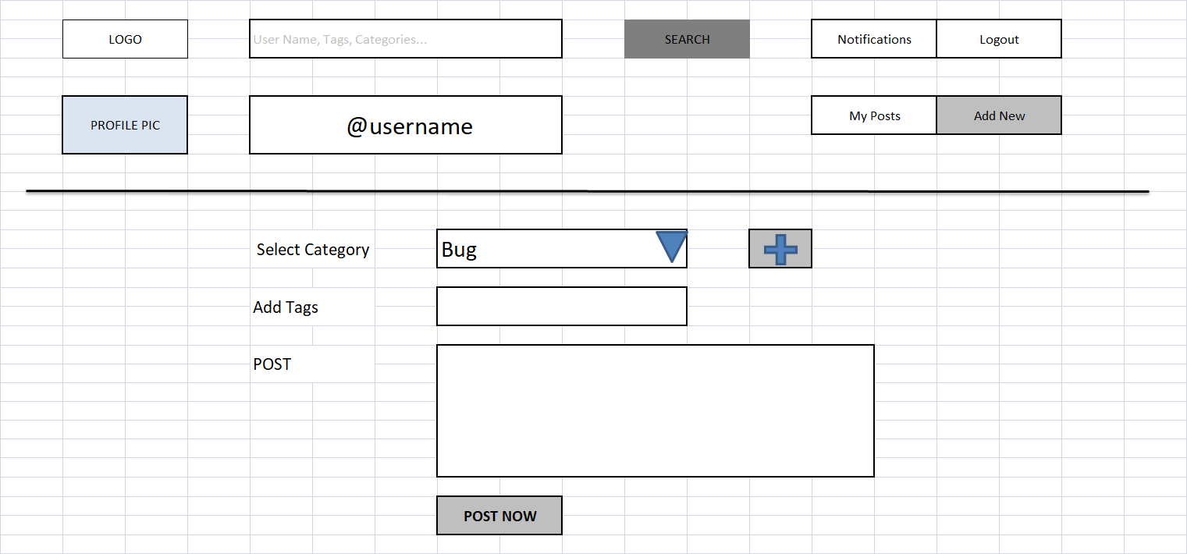

# Display Posts

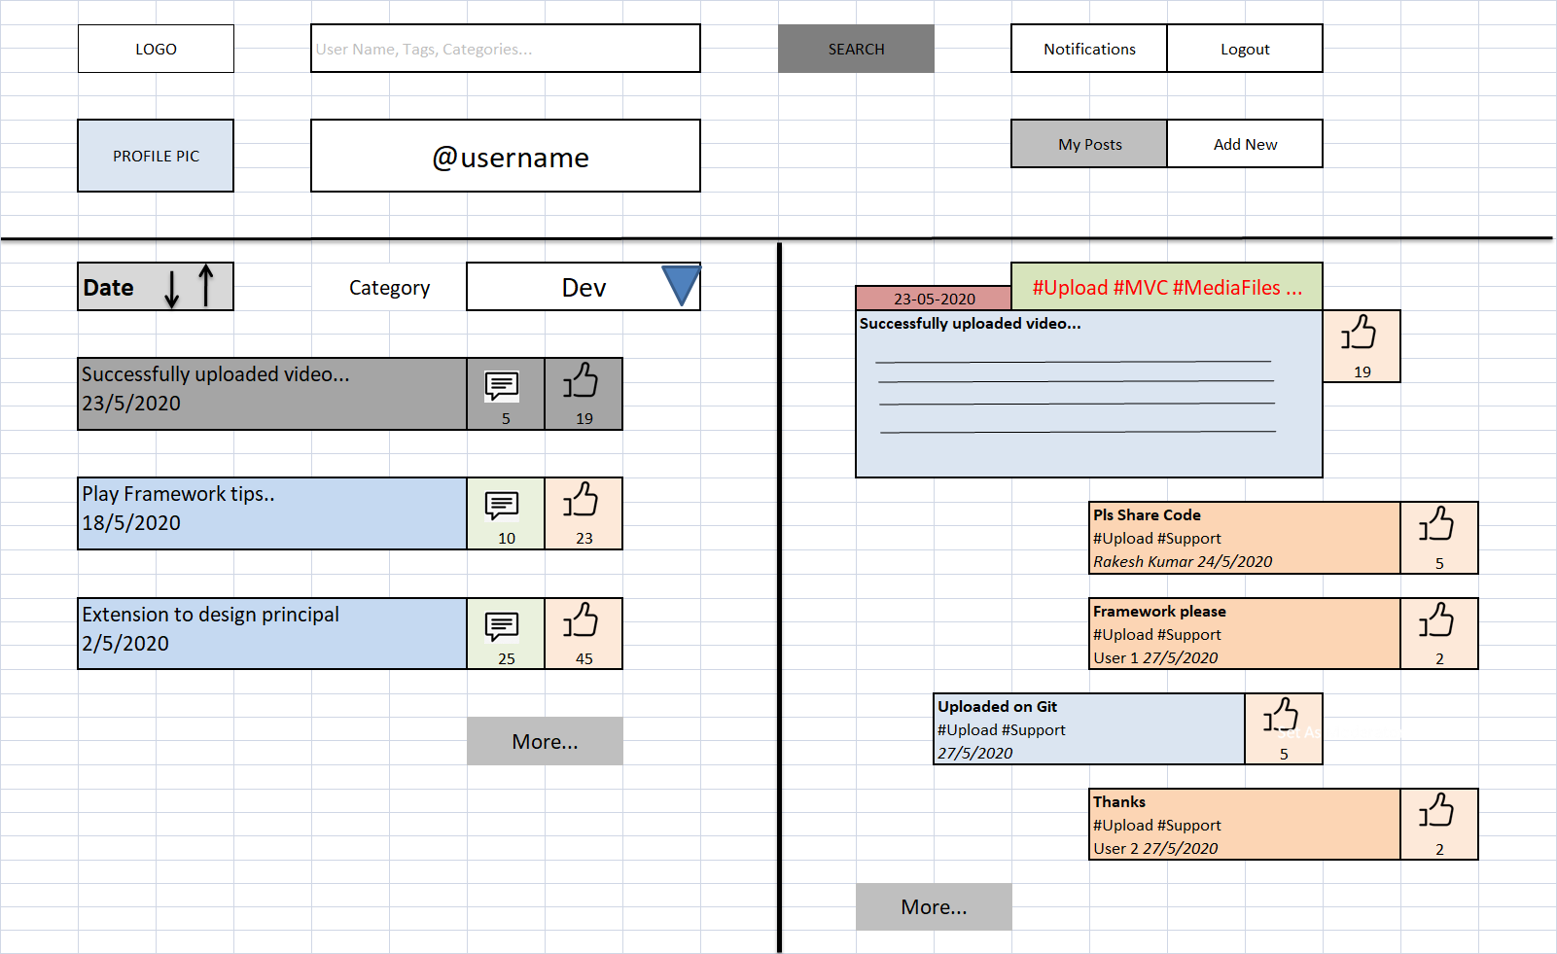

# Search Wireframe

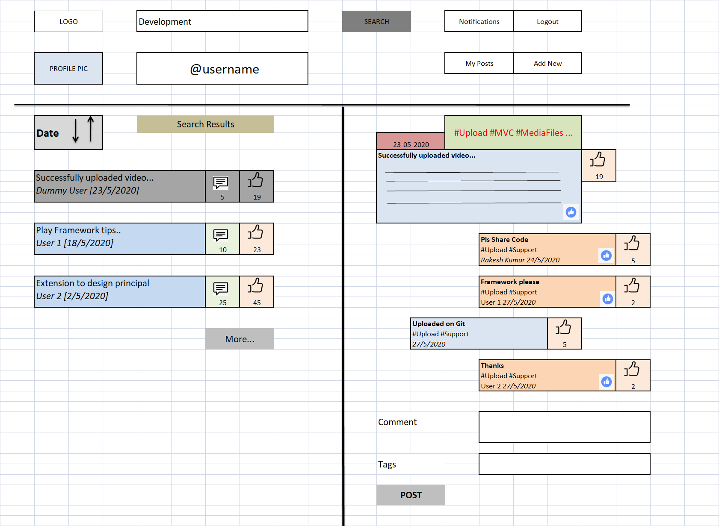

# Admin User management

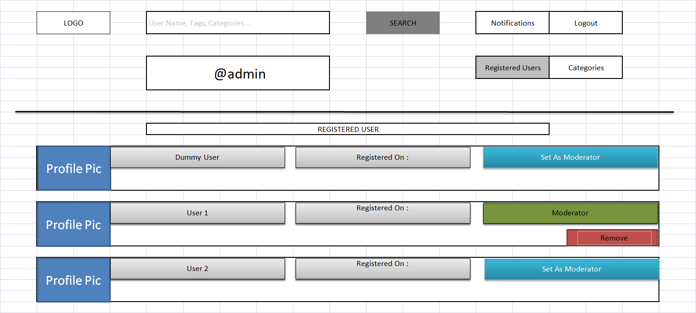

# Admin Category Management

